**THANAL**

**A CENTRE FOR BEFRIENDING PERSONS IN DISTRESS AND IN DANGER OF SUICIDE**

**Reg.No.16 / IV / 2002**

##### Near Malabar Christian College, Kozhikode

##### PHONE: (0495) 2725555, 3279307, 2546111

###### **I am the founder director of Thanal – means shade (from 2001 to 2006) and the secretary of Thanal Foundation Trust till date.**

**“Thanal”,** isa centre for befriending persons in distress and in danger of suicide was instituted by Indian Medical Association, Kozhikode Branch in the year 2001. **Thanal** is functioning at Kozhikode city trained to identify persons with suicidal tendencies and be of help to them.

###### **Objectives**

* To ensure that volunteers are available at any hour of the day or night to offer emotional support to those passing through personal crisis and in imminent danger of taking their own lives.
* To conduct training programs for social workers, teachers, religious personnel, N.S.S. volunteers, health workers, etc. to intervene in the lives of suicide-prone persons.
* To undertake research projects on suicide in Kerala and to develop models for effective intervention strategies.
* To make available expertise to start suicide prevention programs in other parts of the state.

###### **Thanal Befriending Activites**

**Thanal** Befriending Centre remains open every day of the year including Sundays and holidays from 10.00 A.M. to 6.00 P.M. We hope to be able to provide round the clock service as we progress.

###### **Callers**

Any person going through a period of personal crisis and wants to share his feelings to someone in strict confidence is welcome to utilize services of the befriending centre. Persons going through crisis due to a variety of reasons such as death, terminal illness, loneliness, marital discord, financial problems, employment problems, depression, and educational backwardness, and hence harboring suicidal thoughts and wanting to unburden him/her to an understanding person may call to or visit Thanal. He/she will find someone waiting for him. Our services are free. He/she may walk into Thanal without prior appointment and find in the waiting volunteer a trustworthy friend who will listen to him/her without being judgmental. He/she can contact Thanal by telephone as well (Number-0495-2725555). Alternately, he/she can communicate by letters. He/she is sure to receive a prompt reply.

###### **Confidentiality**

Callers to Thanal are assured of complete confidentiality about what they share with the befriender. The volunteers will not divulge the problem to any one outside the centre, or even to their spouse or children. To the caller, the befriender will be identified by his first name. Their personal details will not be disclosed. The caller in turn is not required to reveal his/her personal details.

###### **Volunteers**

A team consisting of senior members of Befrienders India has carefully selected the volunteers. They are trained adequately to undertake this mission. It should be mentioned here that listening to another person particularly to one in distress is by no means an easy task. The volunteers from Maithri (Kochi & Thrissur) and Sneha (Madras) have provided the expert training for the volunteers. Persons committed to the cause of a healthy society, who have the capacity to listen without being judgmental and having the time to spare four hours in a week can become the volunteers of Thanal. Persons of either sex, of any age, of any cast can come forward. There will be selection for the volunteers once in every six months.

###### **Befrienders India**

**Thanal** functions under the umbrella of Befrienders India, the national unit of Befrienders International. Befrienders International is the federation of national bodies of the befriending centers operating in many countries worldwide, which provides only technical support in establishing such centers. Rev.Chad Varah in the city of London started this movement in 1953. Befrienders India is a non-religious and non-political organization, which was started in 1992. It aims to generate awareness of suicide, help to open new centres in different cities, raise funds, and collate and distribute information on suicide in India and abroad. Presently there are 13 centers in New Delhi, Kolkata, Mumbai ,NaviMumbai, Ahamedabad, Chennai, Secundarabad, Cochin, Pondichery, Kozhikode, Thrissur, North Paravoor and Irinjalakuda under this organization.

###### **Report of activities**

###### **2002 -2003**

|  |  |  |
| --- | --- | --- |
| Date | Programme | Venue |
| 25.01.02 | Public Programme on Suicide Prevention | Town Hall, Kozhikode |
| 09.02.02 | Suicide Prevention – for Doctors & Public | IMA Hall, Kozhikode |
| 10.03.02 | World Women’s Day – Talk on Suicide Prevention | IMA Hall, Kozhikode |
| 26.05.02 | Public Programme on Suicide Prevention | Fed. Club,Thamarasseri |
| 27/28/29 May | 24 Hour helpline service- SSLC result | Iqra Hospital, Kozhikode |
| 19.06.02 | Public Programme | NSF, Kunnamangalam |
| 25.06.02 | Class on Suicide in Children & adolescents | Med. College, Calicut |
| 19.09.02 | Public Programme on Suicide Prevention | Thiruvannur, Calicut |
| 10.10.02 | World Mental Health Day | Mofussil Bus Stand, Kozhikode |
| 03.11.02 | Continued Medical Education Programme on Suicide Prevention Strategies for Primary Care Givers | IMA, Kozhikode |
| 22.12.02 | Outreach Programme for Nanma-Seminar on Suicide Prevention | Kackoor, Kozhikode dt. |

###### **2003-2004**

|  |  |  |
| --- | --- | --- |
| 13.03.2003 | 24 hour befriending for SSLC students and Parents to alleviate anxiety for three days | Iqra Hospital, Kozhikode |
| 01.04.03-31.05.03 | Stall at Exhibition ground to create awareness among general public on suicide. | Corporation Exhibition Ground |
| 28.04.2003 | Book release “Athmahathyayum Pradhirothavum” by Thanal | IMA Hall, Kozhikode |
| 14.05.03 | Programme on Akashavani on Suicide Prevention | Broadcast by AIR |
| 14.05.03 | 24 hour befriending for 3 days during SSLC results | Iqra Hospital, Kozhikode |
| 16/18.05.03 | Programme for High School Students- Exam Anxiety, Human Values, Positive thinking etc. | IMA Hall, Kozhikode |
| 01.10.03 | Thanal Website Inauguration | Town Hall, Kozhikode |
| 28.11.03 | Seminar on Factors that Contribute to the Suicidal Tendencies for Students and Parents | St. Vincent Colony School, Kozhikode |
| 10.01.04 | Class on Suicide, Addiction and Awareness Programme | Chelambra Panchayat, Malappuram |
| 24/25.01.04 | Presentation on topic “Suicide – current research/study in Kerala by Dr. Suresh Kumar | Dept. of Future Studies, Univ. of Kerala, Trivandrum |
| 14.02.04 | Special Feature on Thanal in Arogyavani | Akashavani, Kozhikode |
| 22.02.04 | Public Awareness Programme | IMA Hall, Vadakara |
| 10.03.04 | 24 hour befriending for SSLC students & Parents for 3 days | Iqra Hospital, Kozhikode |
| 28.03.04 | Class for Municipal High school students, Iringal | Iringal, Vadakara |
| 30.03.04 | Class on Suicide Prevention for High School students | Parambil Bazar, Kozhikode |
| 30.04.04 | Seminar on Farmer’s Suicide problems & solutions | Town Hall, Kozhikode |
| 10.05.04 | 24 Hour Befriending Session for 3 days during SSLC results | Iqra Hospital, Kozhikode |
| 10.09.04 | Workshop on Role of Media in Suicide Prevention | IMA Hall, Kozhikode |
| 09.10.04 | Class on Mental Health Awareness | Naduvannur Panchayat, Kozhikode |
| 10.10.04 | Class on Suicide Prevention at Badirur, Kakkodi | Kakkodi, Kozhikode |
| 19.10.04 | Awareness Class for Long Route Drivers | IOC, Gas Filling station, Kozhikode |
| 22.10.04 | Class on “How to Avoid Mental Strain“ for Anganvadi workers | Karaparamba, Kozhikode |
| 28.11.04 | Class on Drugs, Liquor addiction and Suicide at Chaliyar | Chaliyar, Malappuram |
| 20.12.04 | Public Awareness Programme by Thanal & Akashavani | Town Hall, Kozhikode |

**2005**

|  |  |  |
| --- | --- | --- |
| 02.02.2005 | Class on “Suicide among students” at Headmasters’ Meeting | DEO’s Office, Calicut |
| 14.03.05 | 24 Hour Befriending Service for SSLC students and Parents | Iqra Hospital, Kozhikode |
| 26.03.05 | Class on “Problems of Adolescents” at Chevarambalam | Chevarambalam, Kozhikode |
| 8/9.04.05 | Training for volunteers of Santhwanam Suicide Prevention Centre,IMA, Vadakara | IMA,Vadakara |
| 12.04.05 | Student Counselling at Govt. Teacher Training Institute | East Nadakkavu, Kozhikode |
| 21/05/05 | Class for Girls of ages 11 to 19 | AUP School, Malaparamba |
| 03.07.05 | Counselling programme for SSLC and Plus 2 students | Shakthi Theatres, Kuruvangad |
| 08.09.05 | Class on Suicide Prevention for Parents of Girls on Girls Day | Bhodhana Swasraya federation, Calicut |
| 14.09.05 | Outreach programme at Balussery | Balussery, Calicut |
| 10.09.05 | World Suicide Prevention Day | Mofussil Bus Stand, Kozhikode |
| 05.11.05 | “Manoranjini” Music Therapy Programme | IMA Hall, Kozhikode |
| 13.11.05 | Phone in programme of Thanal at Akashavani | Broadcast from AIR, Kozhikode |
| 14.11.05 | Class at One Day workshop by Childline & Shikshan Sansthan on “Rights of Children” | Hotel Renaissance, Kozhikode |
| 02.12.05 | Class for Girls of Plus 2 on “Problems of Youth with special attention to Suicide thoughts among youth” | Ganapath Girls High School, Chalappuram, Kozhikode |
| 09.12.05 | Classes on” Suicide – Public Health Hazard” and Suicide Prevention and Suicide & Women at Muthu Bazar | Cheliya, Kozhikode |
| 09.12.05 | Seminar on “Problems of Youth” at JDT Islam College | JDT Islam College of Arts & Science |

###### **2006**

|  |  |  |
| --- | --- | --- |
| 13/14.01.06 | Training Programme for New Volunteers of Santhwanam Suicide Prevention Centre, Vadakara | IMA Hall, Vadakara |
| 18.01.06 | Class for students of JDT Islam Vocational Higher Secondary School | JDT, Kozhikode |
| 26/29.01.06 | 4 days Exhibition by Health Care Society, Ponoor, Unnikulam, Thanal Stall for Suicide Awareness | Unnikulam, Calicut |
| 26.01.06 | Class on Mental Health & Harmony and “Increasing suicides in our Society” at Grama Chethana Karalapyil | Kokkallur, Calicut |
| 05.02.06 | Class on Suicide Prevention at Mokavoor | Eranhikkal, Kozhikode |
| 16.02.06 | Debate on “Women & Suicide” | Town Hall, Kozhikode |
| 20.02.06 | Seminar on Suicide on Adoloscent Girls | Vavanad ,Kalpetta. |
| 25.02.06 | Class on “Mental Health and Family Harmony” & “Suicide & Contemporary Society” | Kayanna Bazar, Perambra, Kozhikode |
| 11.03.06 | Class on “Child Psychology” and “Effect of Media on Children” | Samskruthi School, Panthavoor, Malappuram |
| 23/30.03.06 | One Week Mobile Public Awareness Programme on Suicide Prevention | Sultan Battery, Pulpally, Meenangadi, Panamaram, Mananthavadi, Pozhuthana, Kalpetta, Ambalavayal, Meppadi etc. |
| 31.03.06 | 2 days Class on Mental Stress & Strain and Adoloscent Problems at G.T.T.I, Nadakkavu | Nadakkavu, Kozhikode |
| 20.05.06 | Class on “Stress Management” at Aramam Family Meet | Kozhikode |
| 10.09.06 | Suicide Prevention Day with Awareness Programme at Mofussil Bus Stand | Kozhikode |
| 01.11.06 | 5th Anniversary ofThanal with CD release and Drama “Samavarthanam” | Town Hall, Kozhikode |

###### **2007**

|  |  |  |
| --- | --- | --- |
| 12.01.07 | Seminar on “Suicide Prevention” for Govt. Servants | IMHANS, Kozhikode |
| 10.03.07 | Class on Examination Anxiety for Teachers & Parents | NSS UP School, Eranhikkal |
| 09.03.07 | Mobile Outreach Programme at Waynad | Wayanad |
| 17.04.07 | Magic Show with Suicide Prevention as Theme by Renouned Magician Gopinath Mudukad | Gujrathi School Auditorium, Kozhikode |
| 16.05.07 | Awareness lecture on Suicide Prevention for members of Govt. Pensioners Association at New Nalanda | Nalanda, Kozhikode |
| 01.07.07 | Class on Listening Skills for Paliative Volunteers & Social Workers | Edappal, Malappuram |
| 09.09.07 | Two Day State Level Work Shop for Organizations and Individuals working in the Field of Suicide Prevention, New Nalanda | Hotel New Nalanda, Kozhikode |
| 10.09.07 | Public Meeting on World Suicide Prevention Day | Town Hall, Kozhikode |

**2008**

|  |  |  |
| --- | --- | --- |
| 09.01.08 | Class on Mothers & Adolescent Girls | Anganvadi, Chulliode |
| 16.01.08 | Class on Adolescent Age | Anganvadi, Azhchavattom |
| 24.01.08 | Class on Adolescent Age | Anganvadi, Narikkuni |
| 02.02.08 | Class on Adolescent Age | Sri Devi Vilasam School, Mannur |
| 12.02.08 | Class on Adolescent Age | Kadalundi School, Kadalundi |
|  | Examination Stress for Students of NSS, Karayogam School and PVS High School, Eranhikkal | Eranhikkal, Kozhikode |
| 14/15.07.08 | Training for New Volunteers at Santhwanam Suicide Prevention Centre, Vadakara | IMA, Vadakara |

**2009**

DATE

PROGRAMME

VENUE

10/1/2009

Class on Examination Stress

Vedavyasa School, Malaparamba

12/1/2009

Class on Suicide Prevention

Civic Charitable Trust,Calicut

17-01-09

Class on Good Parenting

Vedavyasa School, Malaparamba

24-01-09

Class on Good Parenting

Mathrusamithi, Panniyankara

2/2/2009

Class on Examination Stress

PVS School,Eranhikkal

18-02-09

Talk On' Family values' for Mothers

Civil Station UP school

26-02-09

Talk on Nutrition and Child Care

Anganvadi, Chulliyode,Calicut

21-03-09

Awareness programme Suicide and Prevention

Aswasa Kendram, Civil Station

24-07-09

Class on Problems faced by children

PTA, Chinmaya Mission School

28-07-09

Class on Suicide among Students

Girls' High School, Calicut

29-07-09

Class on Adolescent Problems

Do

7/8/2009

Talk on Problems faced by Children at home

U P School, Koodathai

7/8/2009

Awareness Programme Suicide and Prevention

Do

7/8/2009

Class on Adolescent Problems

PTA,Koodathai UPS

8/8/2009

Class on Adolescent Problems

Pleasant English medium

School,Omasseri

9/8/2009

Class on Suicide and Prevention

Vanitha Vedi, Mavoor

18-08-09

Talk on How to handle children

UPSchool, Chevarambalam

20-08-09

Talk on Caring for Children at home

Mathrubandhu school, Civil Stn

21-08-09

Do

ChristuRaja School,Malaparamba

10/9/2009

Awareness Programme on Prevention of suicides in

jails

District Jail, Calicut

11/9/2009

Awareness Programme on Suicide and Prevention

MC Colege Higher Sec School

15-09-09

Class on Environmental Pollution &Epidemics

Karuna Anganvadi,Civil Stn

25-09-09

Class on Adolescent Problems

Iquhra Higher Sec School

4/10/2009

Class on Adolescent Problems

Higher Sec School, Parayancheri

7/10/2009

Talk on Family strengths

Govt Model High School

9/10/2009

Class on Adolescent Problems

Govt Higher Sec School,East hill

Class on Adolescent Problems among Girls

Govt Achuthan Girls High School

16-10-09

Class on Adolescent problems among boys and

girls

Govt Higher Sec School, Payyanakkal

1/11/2009

Thanal Celebrates 8th Birthday

Tagore Centenary Hall, Calicut

Talk on Stress

and strain management

8/11/2009

Awareness Programme on Suicide prevention

and.Stress problems

Souhrudam Res Assn, Tiruvannur

15-11-09

Do

Residential Assn, Nallalam

24-11-09

Do

Pulari Swayam Sevak,Meppayur

1/12/2009

AIDS, an awareness programme

JDT Higher Sec school

17-12-09

Class on Adolescent Problems

UP School Malaparamba

23-12-09

Awareness Programme on Suicide prevention

Mukkam

3/11/2009

Nursing college, malabar Eye Hospital

CLT

**2010**



**2011**



**2012**



|  |  |  |
| --- | --- | --- |
| 15-08-2013 | Awareness program for parents of Adolescents | Aganvadi school- Nanmanda panjayath |
| 11-09-2013 | Awareness program for housewives – alcoholism and drug abuse | A mansion at Thankals road |
| 19-09-2013 | Awareness program for Adolescents issue | St. Joseph boys school |
| 26-09-2013 | Awareness program for parents of +1, +2 students | Himayathul HSS |
| 26-09-2013 | Awareness program for parents of +1, +2 students | REC G.V.H.S.School |
| 18-12-2013 | Awareness program for general public | Mofusal bus stand calicut |

**2014-2015-2016**

|  |  |  |
| --- | --- | --- |
| 13-01-2014 | Awareness program for parents of +1, +2 students | Parayancheri boys school |
| 02-03-2014 | Awareness program for SSLC, +1, +2 students- How to overcome examination fear | Residents association- Chelavoor area |
| 16-03-2014 | Publicity program of thanal- notice distribution | Calicut beach |
| 2-03-2014 | Program on the topic- Suicide in adolescents girls and boys | PSM college in Thirurangadi |
| 02-04-2014 | Autism day program | IQRAA Annex – Eranhipalam |
| 24-05-2014 | Schizophrenia day program | Town Hall Calicut |
| 26-06-2014 | International day against drug abuse and illicit trafficking | Town Hall Calicut |
| 13-07-2014 | Awareness program for alcoholic people | IMA hall Calicut. |
| 10.09.2014 | Suicide prevention- Street play- an awareness program | Various places of Calicut |
| 10.10.2014 | World mental health day- observed | Town Hall Calicut |
| 16.10.2014 | Suicide & prevention seminar in collaboration with ‘JANAMITHRI’ police | Balussery community Hall |
| 15.11.2014 | Kottayam Nazeer show- an awareness cum entertainment show in connection with suicide prevention | Tagore hall- Calicut |
| 25.01.2015 | ‘Punarjeni’- car inauguration- mainly for outreach programs and all necessary unit needed for public awareness. | Thanal premises |
| 02.04.2015 | Autism day program | IMA Hall- Kozhikode |
| 24.05.2015 | Observed world schizophrenia day | Town hall- Kozhikode |
| 26.06.2015 | International day against drug abuse and illicit trafficking | Town hall- Kozhikode |
| 10.09.2015 | Suicide prevention day – Bike rally | From Eranhipalam to Kozhikode beach |
| 10.10.2015 | World mental health day- observed | Nalanda auditorium- Kozhikode |
| 02.04.2016 | Autism day program | IMA Hall- Kozhikode |
| 24.05.2016 | Observed world schizophrenia day | Town Hall- Kozhikode |
| 26.06.2016 | International day against drug abuse and illicit trafficking | Town Hall- Kozhikode |
| 10.09.2016 | Suicide prevention day – Vilambaragosha yathra | Through Manachira squire |

**2016 - 2017 - 2018**

|  |  |  |
| --- | --- | --- |
| 19.08.2016 | Home visit by thanal team | westhill |
| 10.09.2016 | World suicide prevention day observation with mahabali and drums | Around mananchira calicut |
| 11.09.2016 | Onam sadya for 2016 by thanal team | With inmates of ashabhavan calicut |
| 10.10.2016 | World mental health day observation | Medical college premises,bus,stand and beach calicut |
| 28.10.2016 | Home visit by thanal team | Near Calicut university |
| 01.11.2016 | Home visit by four volunteers | Near nirmala hospital calicut |
| 19.11.2016 | annual day celebration,”thanal sandhya” with musical nite | Gujarathi hall calicut |
| 25.02.2017 | Thanal Notice distribution programme | Medical college campus |
| 19.03.2017 | Home visit by two volunteers | Pullorampara, calicut |
| 02.04.2017 | Autism awareness programme with ima and psychiatry wing iqra | Ima hall calicut |
| 07.04.2017 | World health day observation With ima and psychiatry wing iqra | Ima hall calicut |
| 24.05.2017 | World schizophrenia day observasion observation With ima and psychiatry wing iqra and kmct medical college | Ima hall calicut |
| 26.06.2017 | International day against drug abuse With ima and psychiatry wing iqra and kmct medical college | iqra hospital annexe eranhipalam |
| 10.09.2017 | World suicide prevention day with thanal anniversary celebration (digital drama ‘‘mam vidhie’’) | town hall calicut |
| 10.10.2017 | World mental health day observassion | town hall calicut |
| 29.10.2017 | Outreach programme by 9 volunteers. With Awareness classes | moozhikku meethal, east of koyilandi |
| 19.11.2017 | World day for the prevention of child abuse (child line school jagratha samithi bachpan bachao andholan, psychiatry wing iqra and kmct) | Ima hall kozhikode |
| 01.05.2018 | Refresher training to thanal volunteers by adv. litto | Ima hall kozhikode |
| 24.05.2018 | World schizophrenia day observassion | Ima hall kozhikode |
| 26.06.2018 | World anti drug day 2018 | iqra hospital annexe eranhipalam |

**Suicide prevention activities in Wayanad District**

1. In response to the newspaper reports of increasing suicide rate in Wayanad in March 2004, Thanal conducted a home visit pilot Psychological autopsy study Based on this report and a project submitted Govt. of Kerala selected Thanal to carry out suicide prevention activities in Wayanad District.

2. Conducted suicide prevention classes and seminars along with the outreach mental health camps.

1. Thariyode (23-4-04, 17-3-05, 12-04-06, 18-03-07, 13-04-08, 23-04-09, 21-02-10, 17-03-11, 26-02-12, 15-03-13, 21-03-14, 14-04-15, 21-03-16, 14-03-17, 21-02-18)

2. Pulpally (28-4-04, 21-3-05, 17-04-06, 20-03-07, 18-04-08, 21-04-09, 23-02-10, 19-03-11, 23-02-12, 18-03-13, 23-03-14, 16-04-15, 23-03-16, 19-03-17, 23-02-18)

3. Mepadi (16-04-04, 23-3-05, 20-04-06, 22-03-07, 20-04-08, 25-04-09, 25-02-10, 21-03-11, 20-02-12, 20-03-13, 25-03-14, 18-04-15, 25-03-16, 21-03-17, 25-02-18).

These sessions were attended by patients, care givers, public, NGOs and Kudumbasree members

3. Conducted training programmes each year (22-07-04, 29-07-05, 04-08-06, 21-07-07, 21-06-08, 20-06-09,18-06-10, 18-06-11, 17-05-12, 19-07-13, 14-06-14, 19-06-15, 20-06-16, 22-06-17 & 09-08-18) at Kalpetta for Medical Officers and Para-medical staff using training modules and pre and post training assessment schedules (developed by Thanal) on “Detection, Treatment and Prevention of suicides”.

4. Public awareness programmes

* 1. Kalpetta (17-7-04, 21-4-05, 17-05-06, 20-04-07, 18-05-08, 21-05-09, 23-03-10, 19-04-11, 23-03-12, 18-04-13, 23-04-14, 16-05-15, 23-04-16, 19-04-17, 23-03-18)
  2. Meppadi (18-08-04, 21-5-05, 17-06-06, 20-05-07, 18-06-08, 21-06-09, 23-04-10, 19-05-11, 23-04-12, 18-05-13, 23-05-14, 16-06-15, 23-05-16, 19-05-17, 23-04-18)
  3. Pulpally (24-08-04, 23-6-05, 20-07-06, 22-06-07, 20-07-08, 25-07-09, 25-05-10, 21-06-11, 20-05-12, 20-05-13, 25-06-14, 18-07-15, 25-06-16, 21-06-17, 25-05-18)
  4. Meenangadi (14-09-04, 23-7-05, 20-08-06, 22-07-07, 20-08-08, 25-08-09, 25-06-10, 21-07-11, 20-06-12, 20-06-13, 25-07-14, 18-08-15, 25-07-16, 21-07-17, 25-06-18 )
  5. Porunannur (22-09-04, 23-8-05, 20-07-06, 22-08-07, 20-09-08, 25-09-09, 25-07-10, 21-08-11, 20-07-12, 20-07-13, 25-08-14, 18-09-15, 25-08-16, 21-08-17, 25-07-18)
  6. Thariyode (23-09-04, 23-9-05, 20-08-06, 22-09-07, 20-10-08, 25-10-09, 25-08-10, 21-09-11, 20-08-12, 20-08-13, 25-09-14, 18-10-15, 25-09-16, 21-09-17, 25-08-18)
  7. Panamaram (24-09-04, 23-10-05, 20-09-06, 22-10-07, 20-11-08, 25-11-09, 25-09-10, 21-10-11, 20-09-12, 20-09-13, 25-10-14, 18-11-15, 25-10-16, 21-10-17, 25-09-18)
  8. Pozhuthana (28-09-04, 23-11-05, 20-10-06, 22-11-07, 20-12-08, 25-12-09, 25-10-10, 21-11-11, 20-10-12, 20-10-13, 25-11-14, 18-12-15, 25-11-16, 21-11-17, 25-10-18)

5. Conducted a pilot study on suicides in Wayanad by compiling and analyzing statistics of suicide in Wayanad for the last 5 years (2013-2017) with special reference to farmers’ suicide.

6. Conducted a psychological autopsy study (2004) to find out the increasing rate of suicides in Wayanad utilizing the health service staff of Wayanad district.

7.Conducted a public awareness programme at St. Martins School Auditorium on 8th December 2017. Dr.P.N.Suresh Kumar, Secretary, Thanal, Dr. Roshan Bijlee and Sri. Johny, Social Worker, Wayanad District took classes.

8.Conducted a training programme at Everglades Auditrium, Kalpetta on 20th February 2017 for School Teachers and Anganvadi workers on suicide prevention. Dr.P.N.Suresh Kumar, Secretary, Dr.Mehroof, Superintendent, Kalpetta General Hospital, Dr. Roshan Bijlee, , Dr. Rajani, Clinical Psychologist, Govt. Mental Health Centre, Calicut took classes.

9. Organized a press conference at Kalpetta Press Club on 21st March 2017 to brief the press about the suicide prevention activities done by Thanal and about the forgoing Mobile Public Awareness Programmes. Dr.P.N.SureshKumar, Secretary, Dr.Sasidharan, D.M.O., Wayanad, Dr.Mehroof Raj, Superintendent, Kalpetta General Hospital spoke a this occasion.

10 Organised mobile public awareness programmes (2004-2017) in collaboration with IMHANS, Wayanad Health Service, Social Work Institutions, Psychiatry Department, Medical College, Trivandrum, Jyothi Nivas, Vazhavatta, Wayanad, Inter Ed-Faculty of Clinical Research, Cochin, Jalam Parathakad, and Desaposhini Vayanasala. The variety of programs include-suicide prevention talks, street play, talking monkey, video/film show, exhibition, and distribution of suicide prevention leaflets.

11.Organized a ‘Public awareness program on suicide prevention at Wayanad’ on 16-12-2017 held at Jacobite Suriyani Church auditorium Poothadi Kenichira Wayanad District.

###### Places covered and time is as follows:

|  |  |
| --- | --- |
| Date | Place |
| 23-03-04 | Sultan Bathery, Pvt. Bus stand |
| 23-03-05 | Pulpally |
| 23-03-06 | Meenangadi |
| 25-03-07 | Panamaram |
| 25-03-08 | Mananthavadi |
| 25-03-09 | Pozhuthana |
| 28-03-10 | Padinjarethara |
| 28-03-11 | Kavumannam |
| 28-03-12 | Kalpetta |
| 29-03-13 | Ambalavayal |
| 29-03-14 | Vaduvanchal |
| 29-03-15 | Meppadi |
| 30-03-16 | Govt. Hospital, Kalpetta |
| 28-03-17 | Padinjarethara |
| 28-03-18 | Kalpetta |

**Programmes conducted in collaboration with IMA**

1. **Workshop on suicide prevention** held on 19th March 2006
2. **Published a** book entitled – **“Suicide Prevention-guidelines for doctors”**
3. **Organizing CME on suicide prevention for medical professionals** on 13-02-05.
4. **State level** public awareness programme on **World Schizophrenia Day** on May 24th 2009
5. **State level** observation of **International Day against Drug Abuse and Illicit Trafficking** – State Program on 26th June 2009
6. **State level** observation **World Suicide Prevention Day** on 10th September 2009
7. **State level** observation **World Mental Health Day** on 10th October 2009
8. **State level** public awareness programme on **World Schizophrenia Day** on May 24th 2010
9. **State level** observation of **International Day against Drug Abuse and Illicit Trafficking** – State Program on 26th June 2010
10. **State level** observation **World Suicide Prevention Day** on 10th September 2010
11. **State level** observation **World Mental Health Day** on 10th October 2010
12. **S**eminar conducted on “Children with Special Needs” on 20th February 2011
13. **State level** public awareness programme on **World Schizophrenia Day** on May 24th 2011
14. **State level** observation of **International Day against Drug Abuse and Illicit Trafficking** – State Program on 26th June 2011
15. **State level** observation **World Suicide Prevention Day** on 10th September 2011
16. **State level** observation **World Mental Health Day** on 10th October 2011
17. **Public awareness program on suicide prevention** on 16-12-2011
18. **State level** public awareness programme on **World Schizophrenia Day** on May 24th 2012
19. **State level** observation of **International Day against Drug Abuse and Illicit Trafficking** on 26th June 2012
20. **State level** workshop on rehabilitation of psychiatric patients on 12th July 2012.
21. **State level** observation of **World Mental Health Day** on 10th October 2012
22. **State level** observation of **World Suicide Prevention Day** on 10th September 2012
23. **World Autism Day** observation on 2nd April 2013.
24. **State level** public awareness programme on **World Schizophrenia Day** on May 24th 2013
25. **State level** observation of **International Day against Drug Abuse and Illicit Trafficking** on 26th June 2013
26. **State level** public awareness programme on **World Suicide Prevention Day** on September 10th 2013
27. **State level** public awareness programme on **World Mental Health Day** on October 10th 2013
28. **State level** public awareness programme on **World Schizophrenia Day** on May 24th 2014
29. **State level** observation of **International Day against Drug Abuse and Illicit Trafficking** – State Program on 26th June 2014
30. **State level** public awareness programme on **World Suicide Prevention Day** on September 10th 2014
31. **State level** public awareness programme on **World Mental Health Day** on October 10th 2014
32. **State level** public awareness programme on **World Schizophrenia Day** on May 24th 2015
33. **State level** observation of **International Day against Drug Abuse and Illicit Trafficking** – State Program on 26th June 2015
34. **State level** public awareness programme on **World Suicide Prevention Day** on September 10th 2015
35. **State level** public awareness programme on **World Mental Health Day** on October 10th 2015
36. **State level** public awareness programme on **World Schizophrenia Day** on May 24th 2016
37. **State level** observation of **International Day against Drug Abuse and Illicit Trafficking** – State Program on 26th June 2016
38. **State level** public awareness programme on **World Suicide Prevention Day** on September 10th 2016
39. **State level** public awareness programme on **World Mental Health Day** on October 10th 2016
40. **State level** public awareness programme on **World Schizophrenia Day** on May 24th 2017
41. **State level** observation of **International Day against Drug Abuse and Illicit Trafficking** – State Program on 26th June 2017
42. **State level** public awareness programme on **World Suicide Prevention Day** on September 10th 2017
43. **State level** public awareness programme on **World Mental Health Day** on October 10th 2017
44. **State level** public awareness programme on **World Schizophrenia Day** on May 24th 2018
45. **State level** observation of **International Day against Drug Abuse and Illicit Trafficking** – State Program on 26th June 2018

###### **Publications related suicide prevention**

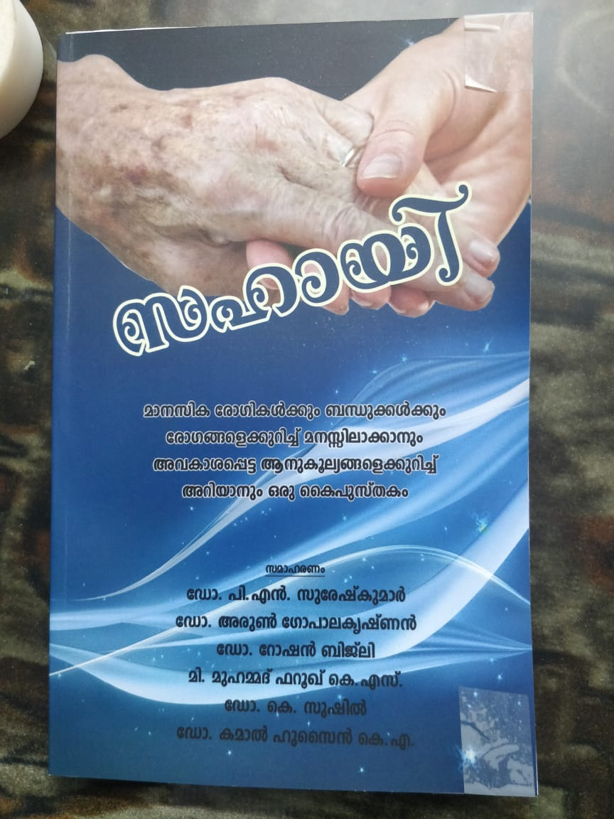 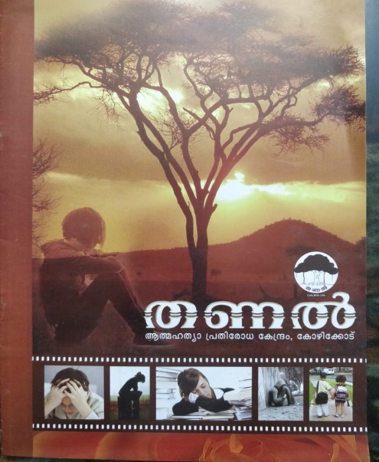

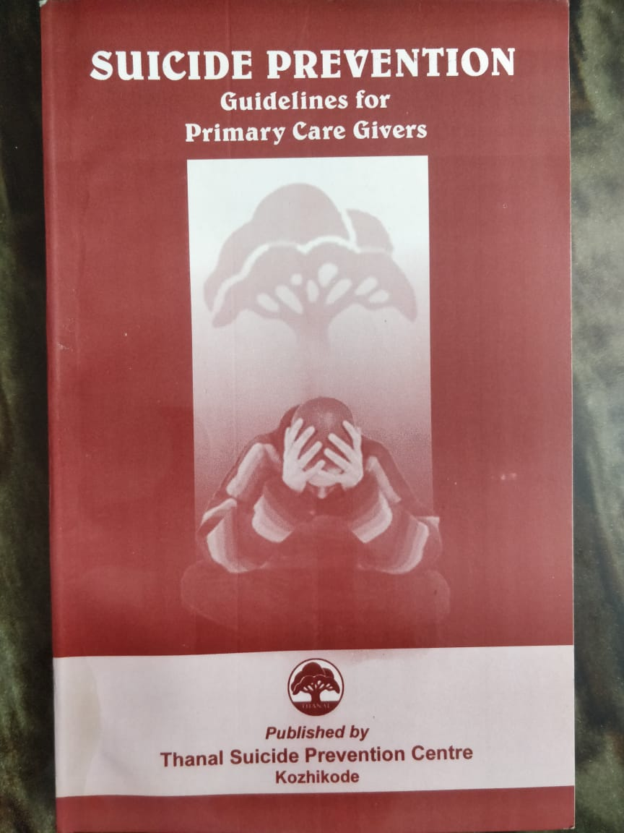 



###### **Outcome of Suicide Prevention Activities in Wayanad**

|  |  |  |  |  |  |  |  |  |  |  |  |  |  |  |  |
| --- | --- | --- | --- | --- | --- | --- | --- | --- | --- | --- | --- | --- | --- | --- | --- |
| Year | **2003** | 04 | 05 | 06 | 07 | 08 | 09 | 10 | 11 | 12 | 13 | 14 | 15 | 16 | **17** |
| Num | **367** | 302 | 320 | 344 | 318 | 338 | 319 | 314 | 288 | 296 | 308 | 284 | 273 | 293 | **276** |

(24.8% reduction)

In the year 2003, prior to starting suicide prevention activities the number of suicides was 367. In the year 2017, number of suicides has been reduced to 276 with a reduction of 99 from 2003 (24.8% reduction). Probably this could be due the vigorous suicide prevention public awareness programs conducted in Wayanad.